Research note on impact of flooding and climate change on informal settlements in Cape Town

Contents

1. Introduction 2

2. Causes of flooding 8

2.1 Types of flooding in Cape Town 8

2.2 Climate dynamics affecting flooding in Cape Town 10

2.3 Landscape factors affecting flooding 13

2.4 Urbanisation factors affecting flood risk 15

2.5 Spatial trends in flood vulnerability 17

3. Impacts 20

3.1 Impact on household assets 21

3.2 Impact on health 24

4. Mitigation 25

4.1 Coping strategies by households 25

4.2 Mitigation by local authorities 27

References 33

ANNEX 1: Flooding research 35

4.3 Local case studies 37

ANNEX 2: Resources 40

4.4 Data sources 40

4.5 Networks / collaborations 40

4.6 Online resources 40

4.7 Contacts 41

4.8 CSIR floods 41

5. Reference list 43

# Introduction

In rapidly growing cities in the Developing South, an increasing proportion of poor urban households live in informal settlements located in areas that are prone to flooding

In Cape Town, persistent flooding and climate change vulnerabilities presents a particularly complex challenge and thus an important case for investigation. Annual winter storms and heavy rains, steep mountainous slopes and long coastlines renders much of Cape Town at risk of flooding.

Flood vulnerability differs markedly between formal and informal neighbourhoods. In formal areas where land use is well-regulated and served by well-designed stormwater and drainage systems, flooding is limited to sudden and localized stormwater overflow flooding when canalized water courses in coastal suburbs are unable to cope with exceptional rainfall events (Ziervogel et al., 2016).

However, the vast majority of the more than 200,000 households living in informal settlements citywide (15-20% of City households) are located on the so-called Cape Flats, a flat, sandy and low-lying plain approximately 700km2 on the southeastern outskirts of the city. This area is transected by several perennial and seasonal rivers and streams, wetlands and detention ponds. As Cape Town is a winter rainfall area, these seasonal water bodies are dry most of the year and thus subject to informal land occupation. It is estimated that more than 30 000 households are displaced annually as a result of flooding (Woods, 2009).

|  |  |
| --- | --- |
| Ponding  (Joubert, 2013) | Run-off, Kosovo  (“Informal settlements in Cape Town provided with flood kits, sandbags,” 2020) |
|  |  |
| Wetland encroachment, Masiphumelele  (Redelmeier, 2018) | Blocked drainage, Masiphumelele  (Ntongana, 2017) |
|  |  |

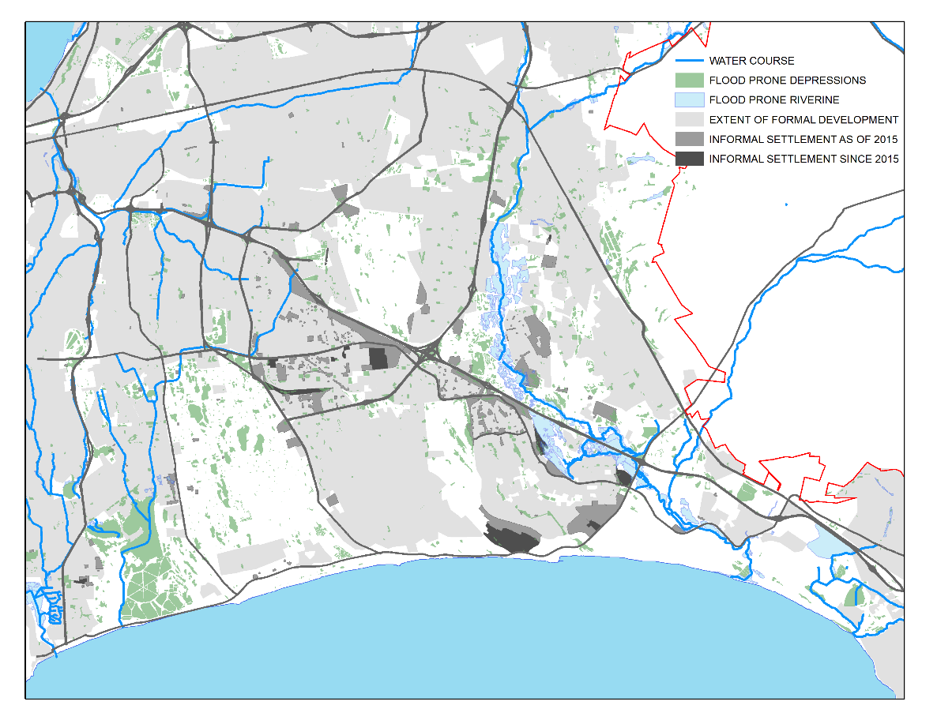

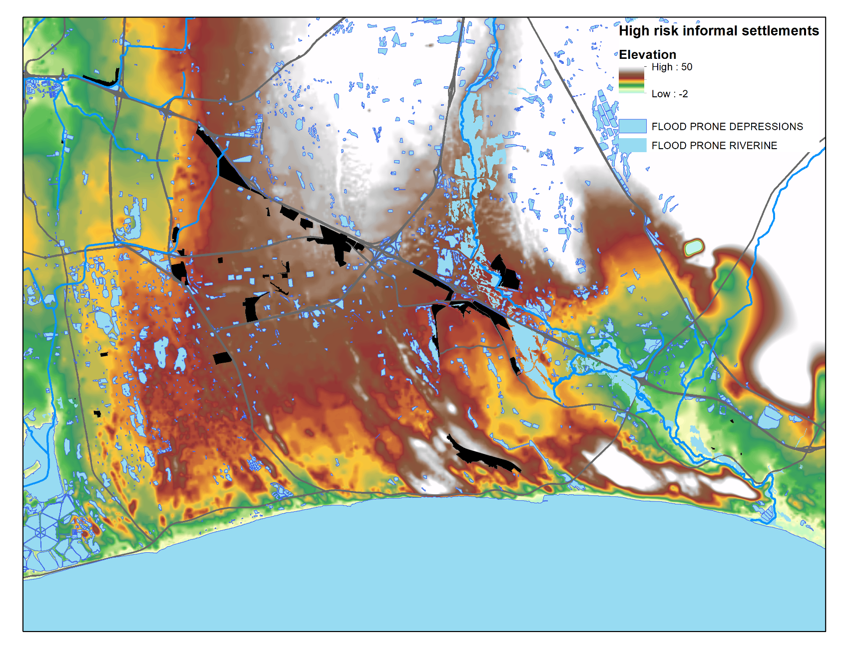

Map indicates location of informal settlements identified as high risk since 2015 by City of Cape Town, in relation to underlying topography of Cape Flats region and flood prone riverine corridors and depressions.

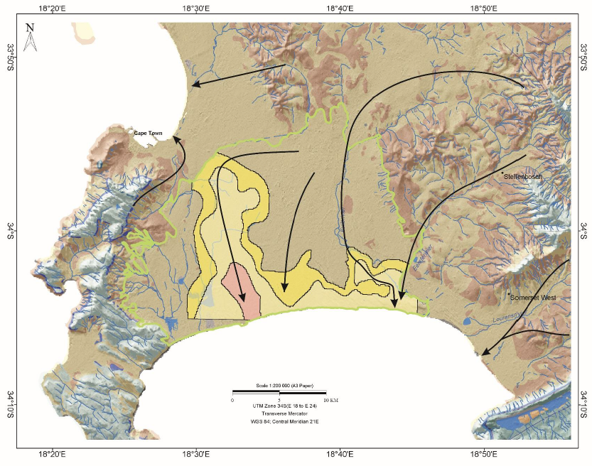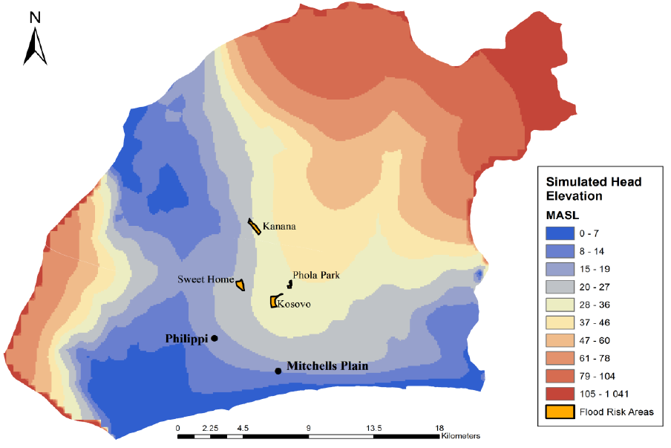

Figure: Simulated mean groundwater head elevation (meters above sea level) for the Cape Flats (2000-2015)

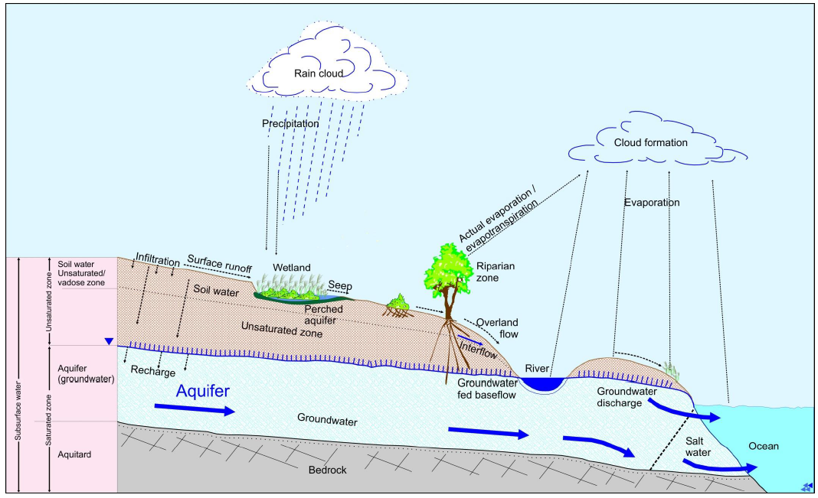

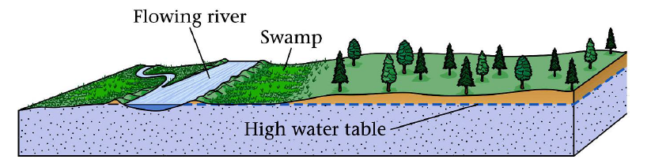

# Causes of flooding

## Types of flooding in Cape Town

Urban areas typically experience a combination of fluvial and pluvial floods, because natural drainage from high-lying areas to flood plains are typically blocked by sealed urban surfaces causing surface inundation.

Cape Town is transected by four perennial rivers: Diep, Elsies, Kuils and Eerste Rivers, and a number of minor creeks and streams. Run-off factors range between 3.8% for Lourens creek at Strand, and 7.2% for Eerste River at Fleurbaai.

In Cape Town, the main types of flooding are pluvial:

(1) seepage caused by a high water table which lies 1-3 meters from the surface in the dry summer months, but rising by 1 to 2 meters in winter months causing localized flooding in topographical depressions;

(2) flooding resulting from expansion of informal settlements into wetlands that appear dry but flood during wetter month.

(3) localized ponding caused by overflowing stormwater channels or inadequate drainage infrastructure

(Pharoah, 2013; Ziervogel et al., 2016)

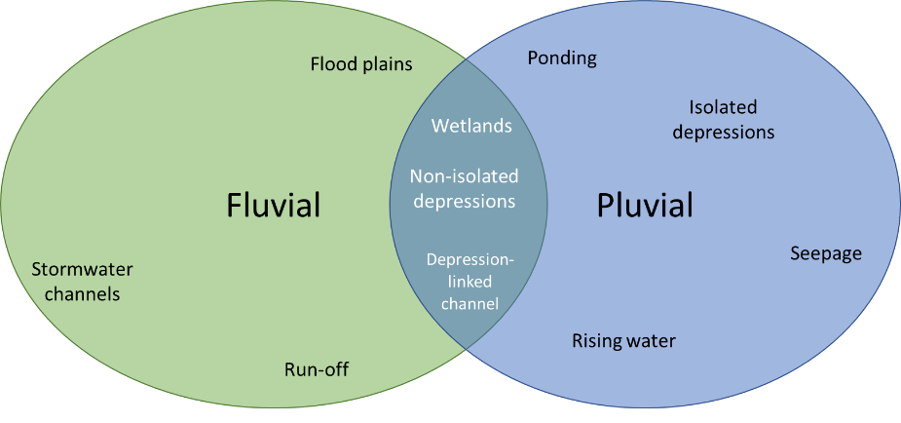

Urban pluvial flooding is defined as “the inundation of property in a built environment, particularly in more densely populated areas, caused by rain falling on increased amounts of impervious surfaces and overwhelming the capacity of drainage systems” (Huang et al., 2019). Urban pluvial flooding only occurs in depressions, which hold storm water that exceeds the capacity of urban drainage systems.

Figure . High water table, Du Noon informal settlement

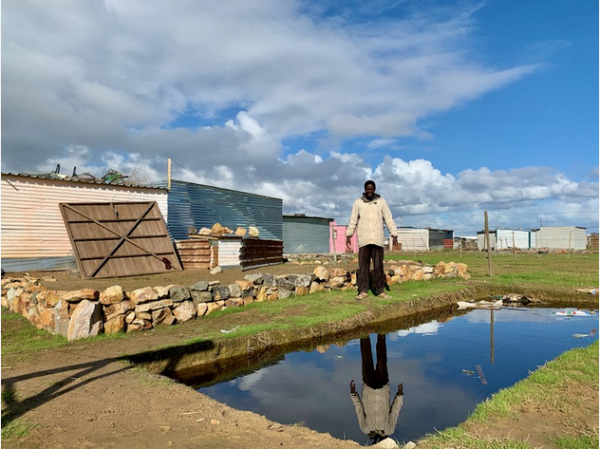

This unlined pool in Doornbach, a newly occupied informal settlement located on a wetland, shows the height of the water table during winter (“Shack with a swimming pool and a Table Mountain view,” 2020).

## Climate dynamics affecting flooding in Cape Town

Cape Town has a warm Mediterranean climate with mild, moderately wet winters and dry, warm summers. Winter, which lasts from the beginning of June to the end of August, sees large cold fronts entering for limited periods from the Atlantic Ocean with significant precipitation and strong winds. The generally mountainous nature of the surrounding Cape Fold Belt results in the entire region having sharp changes in climate (Adelana et al., 2010). The climate varies across different parts of Cape Town: in the Cape Flats, rainfall varies with longitude, from 214mm per year in the East to 800mm in the western parts.

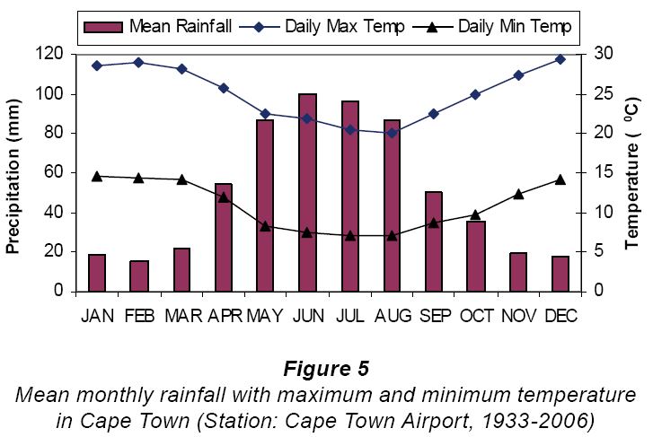

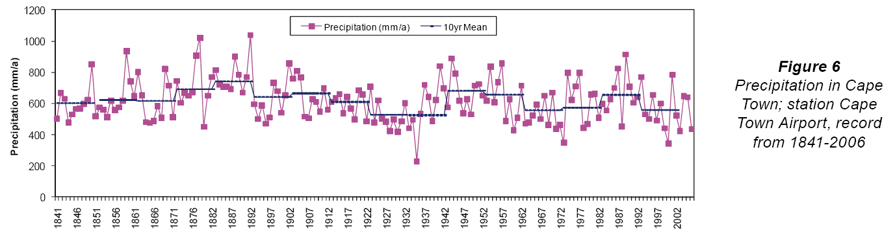

Precipitation at Cape Town Airport (record from 1841-2006), (Adelana et al., 2010).

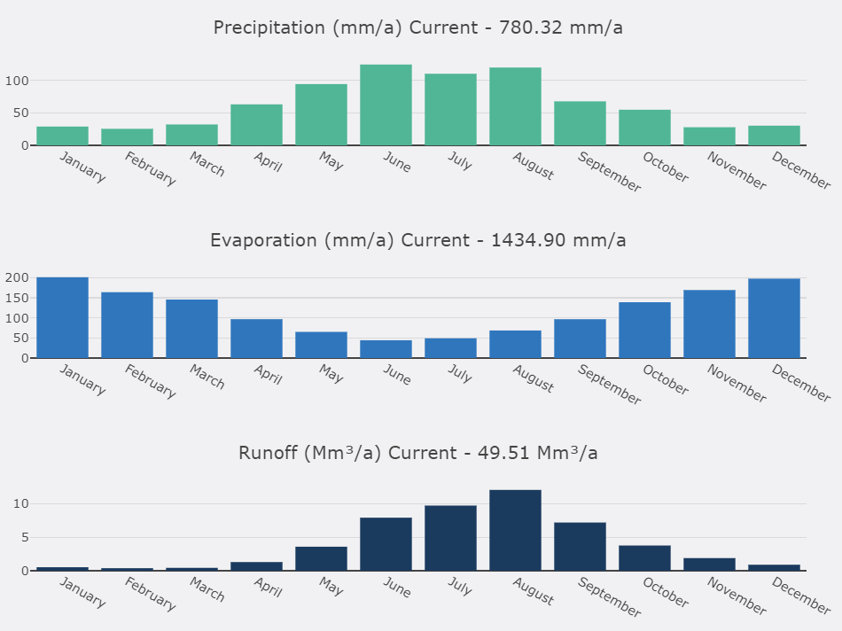

Although Cape Town’s rainfall varies considerably across areas due to the effect of mountains on convection, most regional climate models anticipate that winter rainfall will decline by 150mm by end-of-century (Holloway et al., 2008; Pharoah et al., 2016). These models also predict a reduction in the number of extreme rainfall days relative to 1961-1990 (One World, 2018, p. 23).

Figure

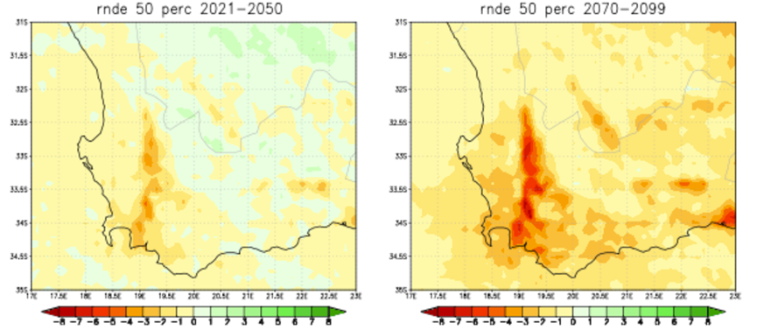

projected change in the annual average number of extreme rainfall days over SW Cape at 8km resolution, for time period relative to 1961-1990, applying central (moderate – 50th percentile)) mitigation scenario. (One World, 2018, p. 23)

However, the models are limited in their ability to predict changes in the number of extreme daily rainfall events, as they are too coarse-grained (as measured by distance between nodes) to estimate convection intensity with rising atmospheric temperatures. In simple terms, regional models are unable to represent local-scale storm dynamics which lead to localized flooding (One World, 2018).

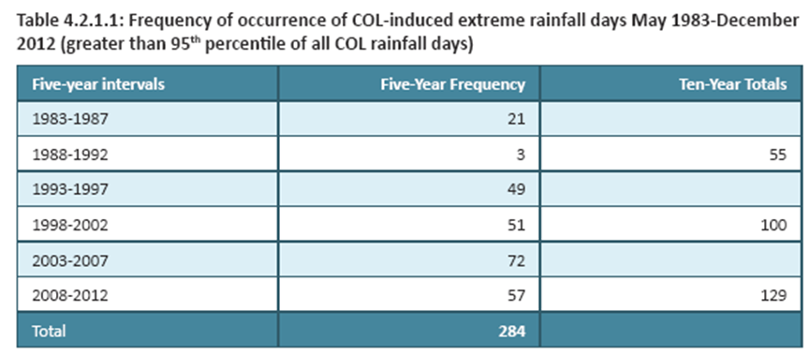

This view is supported by the observed increase in the frequency of extreme daily rainfall in recent years across the Western Cape: the number of extreme rainfall days has increased from 55 from 1983 to 1992, to 100 the following decade, to 129 between 2003 to 2012 (see table below). When comparing 1950-1979 with 1980-2009, an increase of between 30 -60% for the Cape Flats is observed (de Waal et al., 2017). Accordingly, there is broad consensus that storms are likely to become more intense and severe in the future (Holloway et al., 2008; One World, 2018; Pharoah et al., 2016).

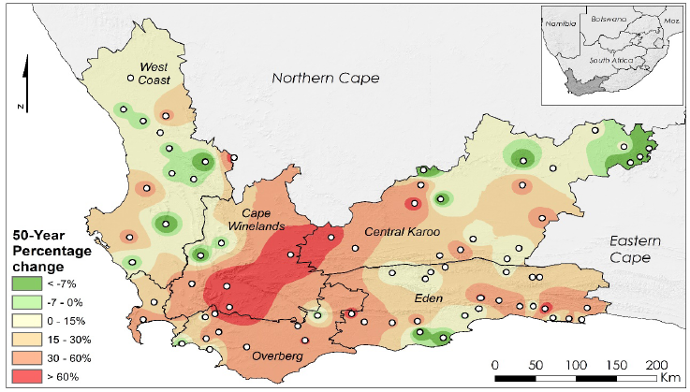

(de Waal et al., 2017)

Figure – inverse distance weighted interpolations of the 50 year 1-day return period rainfall changes % above the 95th percentile thresholds for the Western Cape, from 1950-1979 to 1980-2009.

### Local primary rainfall data

There are few studies which combine fluvial and pluvial flood hazard (Apel et al., 2016). Whereas fluvial flood hazard are typically evaluated by using large scale hydrodynamic models of drainage basins, pluvial flood hazard may be estimated using peak-over-threshold frequency estimation based on local rain gauge data and a stochastic rainstorm generator (Apel et al., 2016).

There are approximately 80 weather stations across Cape Town collected by the South African Weather Services (SAWS). However, complete disaggregated historical data is only available commercially.

Given the high level of variability across Cape Town, data collected from the Cape Town International Airport located near the centre of the Cape Flats was obtained from the National Oceanic and Atmospheric Administration (‘NOAA’) to whom SAWS submits daily reports.

Notwithstanding significant methodological differences and reported concerns about the quality of data from the Airport station, the provisional findings – suggesting a decline in extreme rainfall events from 1977 to 2018 - differ from the longer-term findings of De Waal (1950-2012) which suggests an increase, with extreme rainfall events defined as daily rainfall above the 95th and 98th percentile, was found.

Time series of annual rainfall recorded at Cape Town International Airport, indicating long term decline in extreme rainfall events (as defined by threshold).

## Landscape factors affecting flooding

To date, coarse regional climate change predictions have diverged from observed long-term observed trends in extreme rainfall events. However, the relationship between climate change and flood risk is not limited only to changes in rainfall but significantly influenced by the environmental and human influences on the extent and magnitude of flooding (aside from flooding) (One World, 2018).

The City of Cape Town’s Disaster Risk Management unit identifies four landscape factors affecting flooding in informal settlements:

* Dwellings in trapped low-lying areas without drainage
* Dwellings within 1:20 year floodplains and within 25m of water courses
* Dwellings in wetlands (typically seasonal wetlands dry in summer)
* Dwellings in stormwater detention ponds.

The table below describes the type of factors which increase different types of flood hazard in the Western Cape (adapted from Holloway et al., 2008).

|  |  |  |
| --- | --- | --- |
| Broad source of hazard | Hazard | Factors increasing risk |
| Poor drainage | Ponding | * Poor drainage * Shallow, hand-dug informal drains * Blocked drains * Clogged drainage ditches |
| Surface run-off | * Inadequate drainage alongside hardened surfaces * Structures near hardened surfaces |
| Structural problems | Seepage | * Structures near wetlands and water bodies * Home foundations below ground level * Poor building materials * Inadequate weather proofing |
| Leaks |
| Flood exposure due to location and surroundings | Coastal flooding | * Structures built on sand dunes close to coast * Disturbance of natural water drainage |
| Riverine flooding | * Structures near water bodies * Structures built in dry water courses * Disturbance of natural water drainage and flow patterns |

## Urbanisation factors affecting flood risk

Informal settlement flooding is not only caused by heavy rainfall. The main human cause of flooding is the informal, rapid and mass occupation of large areas of flood-prone wetlands and detention ponds by poor households who build structures from corrugated iron sheets. The propensity for households to locate in flood prone areas is not incidental but attributable in part to the fact that flood prone areas are typically undeveloped or under-developed compared to high-lying areas, which are typically already formally developed.

Since in South Africa courts have pronounced that local authorities are not allowed to evict illegal land occupants from erected structures unless alternative accommodation is provided, these occupation events often resemble a ‘cat and mouse’ game where coordinators launch occupations across a number of Council-owned sites across the city in order to reduce the likelihood of evictions by the local authorities, or alternatively to exact concessions from the City. During these events, families stake out plots of land and erect a structure, often within two hours (GroundUp, 2020). Land occupation events typically occurs in the run-up to winter since local authorities are reluctant to evict during winter.

What follows a successful land occupation event is that the local community demands services from the City, such as electricity, toilets and water. However, the provision of these basic services is often hamstrung by topographical or other engineering difficulties associated with occupation in flood-prone or geographically isolated areas. Although it may be possible for the City to retrofit the newly established informal settlement with drainage channels, households are typically resistant towards re-location from chronically flood-prone areas. Lastly, at least one local case study (Jordhus-Lier et al., 2019) notes that the City’s prioritisation of households living in flood prone areas for social relief measures has in fact created a perverse incentive for households to deliberately opt for flood prone areas.

In formal settlements, engineers plan and build stormwater and other drainage systems to reduce flood risk. Unfortunately, once hundreds of informal dwellings have been built following a land occupation, it is much more difficult to construct adequate drainage, especially in wetlands (Holloway et al., 2008).

This means that informal settlements flooding is driven by:

* Exposure to flooding due to location in high risk areas
* Limited formal stormwater drainage
* Dwelling design that often sinks the informal structure below ground level to stabilize it against wind

(Holloway et al., 2008)

Figure . Land occupation event in Makhaza, Khayelitsha

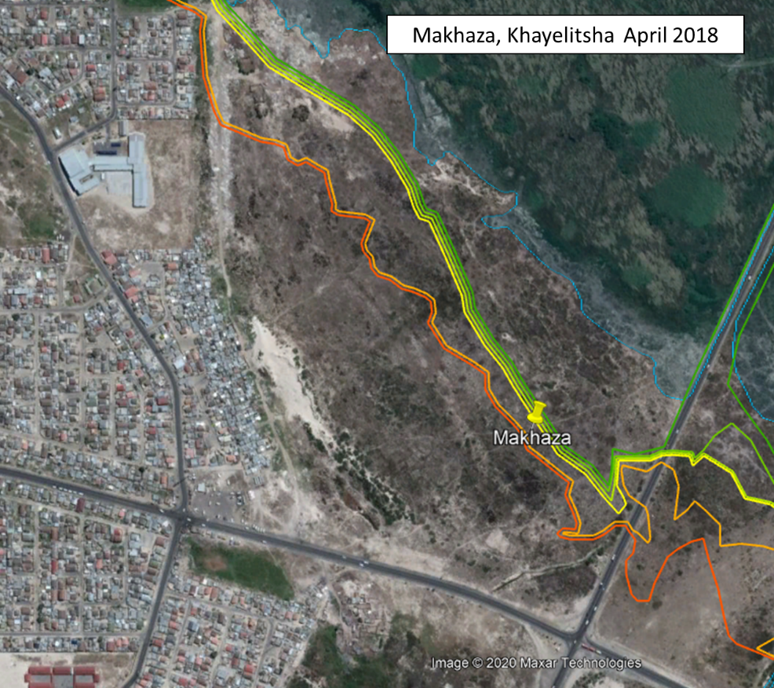

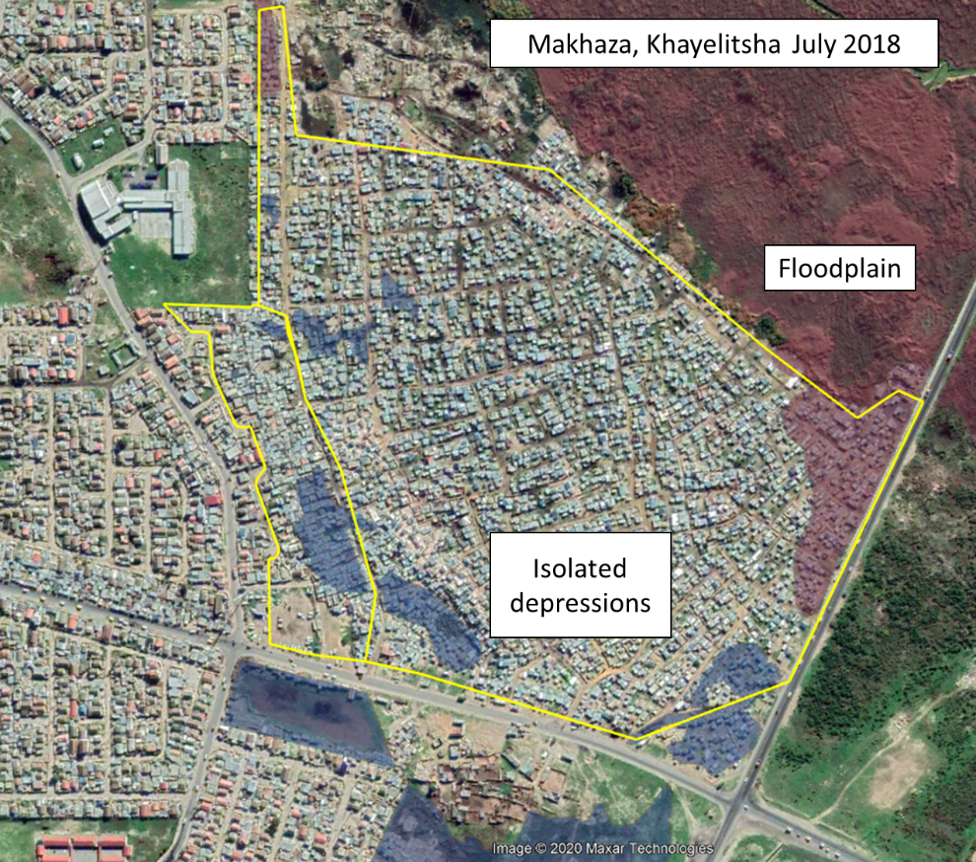

Two Google Earth images before and after land occupation event, indicating extent of 200-year stormwater lines (above) and floodplains and isolated depressions (below) based on data received from the city of cape town.

## Spatial trends in flood vulnerability

As described above, the extent and density of informal settlements as a land use is shown to change abruptly and significantly in a matter of weeks. For the purposes of this research note, the City’s informal settlement layer was updated using the latest satellite photography and the population density inferred by extrapolating the density of structures and average household sizes as observed in 2015 to newly established adjacent settlements. The extent of informal settlements has increased from less than 500 hectares in 1995 to approximately 2854 hectares in 2020.

The extent of informal settlements in nominally flood prone areas (as per observed water bodies) has increased from 17 hectares as of 1995 to 147 hectares in 2020. Until recently, most of these settlements were located on depressions which resulted in seepage. Since 2015 however, there has been a significant increase in the extent of informal settlements on riverine areas (from 10% to 38% of flood-prone structures). This may be attributable to a range of factors, including (1) increasing land scarcity and (2) as a means to receive fast-tracked housing and social benefits from local authorities.

Figure . Number of flood-affected structures over time, by latest date of informal settlement establishment

Figure . Distribution of informal structures across flood prone area types (2020)

Figure . Estimated persons living in flood-affected structures, by latest date of informal settlement establishment

The estimates above are derived by applying local observed average household sizes to the number of structures observed in a given informal settlement. Derived from City of Cape Town data.

Our estimate of just short of 25 000 persons being affected as of 2010 is somewhat lower than the City’s estimate of 32 000 made by Wood in 2009 and cited by Ziervogel (2016). However, this discrepancy may be accounted for by the fact that flooding incidents may occur outside flood prone areas.

# Impacts

The table below describes the type of impacts associated with different types of flood hazard in the Western Cape (adapted from Holloway et al., 2008).

|  |  |  |
| --- | --- | --- |
| Broad source of hazard | Hazard | Effects |
| Poor drainage | Ponding | * Health problems * Missed school and work days |
| Surface run-off | * Health problems * Missed school or work days * Damage to structures * Damage to and loss of assets, documents, possessions |
| Structural problems | Seepage | * Damage to and loss of assets, documents, possessions * Health problems * Missed school or work days |
| Leaks |
| Flood exposure due to location and surroundings | Coastal flooding | * Injuries or deaths * Homes washed away * Damage to and loss of assets * Damage to and loss of infrastructure * Negative effects on businesses and industries |
| Riverine flooding | * Injuries and deaths * Homes washed away * Damage to assets * Damage to infrastructure |

## Impact on household assets

The type of construction used to erect informal structures in flood prone areas is highly homogenous across the study area: small, single-storey shacks built from corrugated iron sheets. A small shack takes about two hours to assemble, with costs ranging from R3400 to R3600 for a one-room shack. A family size shack that can house a double bed and a wardrobe costs about R4600 (GroundUp, 2020). Pharoah estimated in 2013 that it costs approximately R3000 (R4287 in 2020 Rand) to purchase and erect a prefabricated corrugated iron shack (2013). This compares favourably to the 2003 R1100-R1300 estimate of shack construction (Social Housing Foundation, 2008).

According to a 2008 study, 95% of households who rent shacks in informal settlements pay less than R200 a month rent. Average monthly rent for informal settlement shacks was R103 in 2008 (R199 in 2020 Rand), approximately 9% of household income (compared to 14% of income paid by rents of formal backyard dwellings) (Social Housing Foundation, 2008).

No data is obtainable on the value of household contents for informal dwellings in informal settlements. However, an analysis of the Statistics South Africa’s Income and Expenditure data of 2015 found that for Western Cape households earning less than R35 700 per year, consumption was allocated as below:

|  |  |  |  |
| --- | --- | --- | --- |
| **Consumption** |  | **% of consumption** | **Type** |
| **Total** | **23 001** | **100%** |  |
|  |  |  |  |
| Food and beverages | 7 550 | 32.8% | Perishable |
| Transport | 2 432 | 10.6% | Not applicable |
| Clothing | 2 085 | 9.1% | Contents |
| Rental (imputed) | 1 456 | 6.3% | Structure |
| Electricity | 1 663 | 7.2% | Not applicable |
| Debt | 1 326 | 5.8% | Not applicable |
| Communications | 1 054 | 4.6% | Not applicable |
| Furnishings | 720 | 3.1% | Contents |
| Alcohol, tobacco and narcotics | 650 | 2.8% | Perishable |
| Insurance | 565 | 2.5% | Not applicable |
| Water | 564 | 2.5% | Not applicable |
| Personal care | 483 | 2.1% | Contents |
| Health | 178 | 0.8% | Not applicable |
| Dwelling maintenance | 53 | 0.2% | Structure |
|  |  |  |  |
| ***Structure*** | ***1 509*** | ***6.6%*** |  |
| ***Perishable*** | ***8 200*** | ***35.7%*** |  |
| ***Dwelling contents*** | ***3 288*** | ***14.3%*** |  |
| ***Not applicable*** | ***10 004*** | ***43.5%*** |  |

Based on the analysis above, 6.6% of household consumption (imputed rent and dwelling maintenance) is directly linked to the structure of the building, and 14% of consumption relates to dwelling contents (i.e. furnishings, personal care equipment, clothing). 36% of consumption relates to perishable items, and the remaining 44% relates to consumption not directly related to the dwelling. Household contents may thus be estimated by applying depreciation periods of 0.1 to perishable items, and 2 to dwelling contents:

|  |  |  |  |
| --- | --- | --- | --- |
|  | Period | Average | Max |
| Structure |  | 1509 | 3600 (new structure) |
| Perishable items | 0.1 | 820 | 820 |
| Dwelling contents | 2 | 6575 | 6575 |
| Total |  | 8904 | 10995 |

According to Pharoah’s survey of sources of expenditure incurred by households, 34% related to repairing houses and features, 29% on repairing furniture, 14% on repairing clothing. Smaller losses relate to people missing work, replacing groceries or medical expenses.

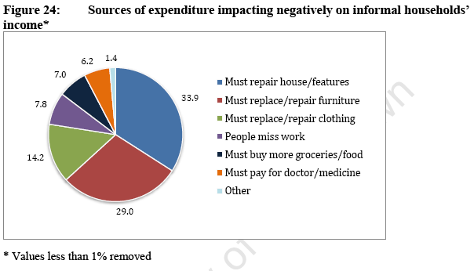

(Pharoah, 2013)

However, when a general survey of households in flood-prone study areas were asked about losses as a direct result of the most serious flooding incident during three years preceding the study, replacing groceries and food (84%) and repairing or replacing furniture (71%) was most frequently cited as the most significant cost.

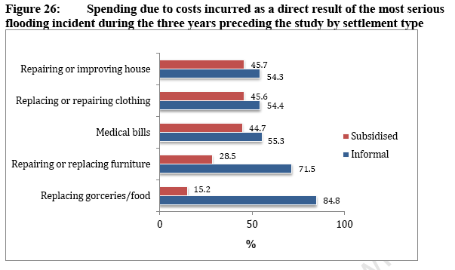

(Pharoah, 2013)

However, when the respondents were subset by households directly affected by the flooding event, the replacement and repair of furniture emerged as the most expensive cost item.

Figure . Spending patterns in flood-affected households

(Pharoah, 2013)

## Impact on health

The health hazards posed by stagnant water was cited most often as a negative consequence of flooding: causing bad odours, stress, flu, asthma, diarrhoea, tuberculosis and rashes (especially for children playing in the polluted water). Flood alleys and paths mean that residents are confined to the relative shelter of their homes, children are unable to go to school and employed residents traipse through ankle-high, muddy water to get to work. Some employed residents skip work to stay home and take care of their shack and/or sick family (Desportes et al., 2016, p. 68).

Flood waters increase humans exposure to pathogens. This is especially true for people living in informal settlements, burdened by high population density, lack of access to basic services and poor sanitation. There is furthermore a significant association between child health and flooding. Types of illnesses reported in the Cape Town informal settlement of Barcelona were mainly water-related, including respiratory illness, gastrointestinal illness, skin and ear infection and vector borne disease. (Machiridza, 2013).

# Mitigation

## Coping strategies by households

### Reactive measures

Most initiatives by residents are reactive and small in scope. In contrast, initiatives that involve significant livelihood shifts, such as saving larger amounts of money to invest in a wendy house were rarely mentioned.

Reactive measures (i.e. implemented after the rain starts) include (1) draining water from the shacks, (2) covering leaking roofs with plastic sheeting, (3) placing buckets under leaking roof, (4) placing cement blocks and crates inside shack to walk on, and (5) taking children to the mobile clinic (Desportes et al., 2016). An additional measures cited by Pharoah include putting down carpeting to absorb water.

### Proactive measures

Proactive measures include (1) digging a trench to redirect water, (2) elevating shack floors, (3) build a wendy house, (4) invest in rain gear and (5) correctly dispose of solid waste and grey water to prevent drain blockages (Desportes et al., 2016).

Putting down a concrete floor was by far the most effective way of addressing flooding, much more so than raising floor with sand or putting carpeting to absorb water (Drivdal, 2016). Sand and rubble are often sourced from around settlements.

However, few residents mentioned the need to elevate their floor levels above ground level, despite this method being perceived by external stakeholders as the most effective strategy for reducing flood risk (see Pharoah’s results below). The digging of channels and the raising of the level of the floor with sand and rubble is more ubiquitous. Households received and depended heavily on sand from the City authorities, who provide high-risk communities with sand in the run-up to winter. (Drivdal, 2016; Pharoah, 2013).

Community-level collaboration is extremely limited, limited to scattering of large stones in alleys and digging of trench around communal tap (Desportes et al., 2016).

Measures taken by households in response to flood risk, based on survey of 511 respondents held in flood-prone areas.

(Pharoah, 2013)

Figure . Examples of proactive measures taken by households

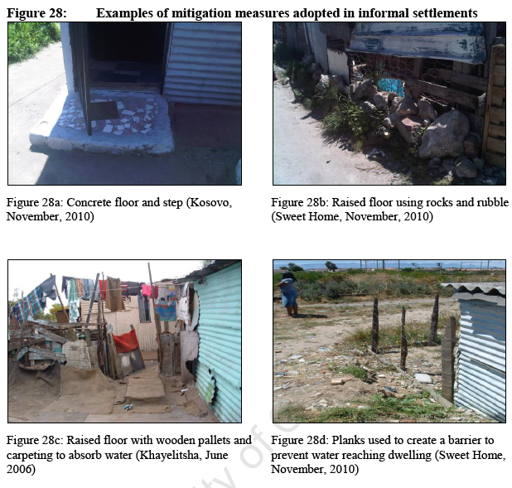

(Pharoah, 2013)

## Mitigation by local authorities

### Institutional arrangements

South Africa’s Disaster Management Act confirms that local government has the mandate for disaster risk reduction and flood management. This responsibility is shared across a number of local government departments, namely:

|  |  |
| --- | --- |
| Department | Responsibilities |
| Development Services | * Located within Human Settlements Directorate * Integration of preparedness and response activities, with objective to mitigate risk of flooding * Established the Flood and Storms Task Team * Provides sand |
| Disaster Risk Management Centre | * Manages the Flood and Storms Task Team * Responsible for risk assessment |
| Roads and Stormwater | * Plays central role on Task Team as result of their in-depth, specialized knowledge of engineering solutions to reduce flooding (e.g. stormwater systems), functioning of informal settlements and localized flood risk * Technology: drains and ponds |
| Informal Settlements Management | * Provide emergency housing flood kits |

(Ziervogel et al., 2016)

The four departments coordinate as part of the **Flood and Storms Task Team**, established in 2008. The Task Team provides the structure for 22 CCT departments to work together to integrate preparedness and response activities, with collective aim of reducing flood risk from annual winter storms. Main strategies are “Winter Preparedness Strategy” and “Flood and Storms Plan”. Their task before the winter season are to identify and develop proactive DRR strategies for high-priority informal settlements that are at risk of flooding, and provide contingency plans for potential flood events across the city (Ziervogel et al., 2016).

The high levels of political contestation around land and development finance have obstructed attempts to development and implement long-term strategies to upgrade Cape Town’s informal settlements. In the absence of coherent long-term strategies, there have been a number of short-term interventions driven by short-term political objectives, with frequent changes in approach and direction (Ziervogel et al., 2016).

### Annual risk assessment

The Task Team conducts an annual risk assessment on 204 informal settlements based on the following criteria:

* Probability (1-5)
* Impact (1-5)
* Vulnerability (1-3)

These criteria are applied in relation to three types of flood risks:

* Water table rise / seepage
* Stormwater
* River / flash flood

Map . Annual risk assessment

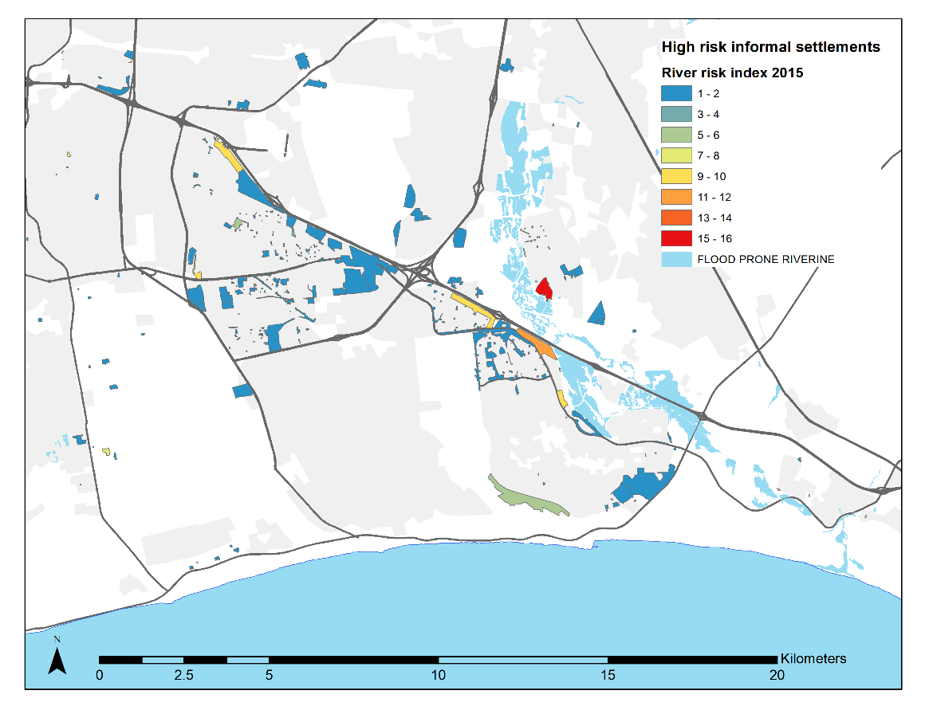

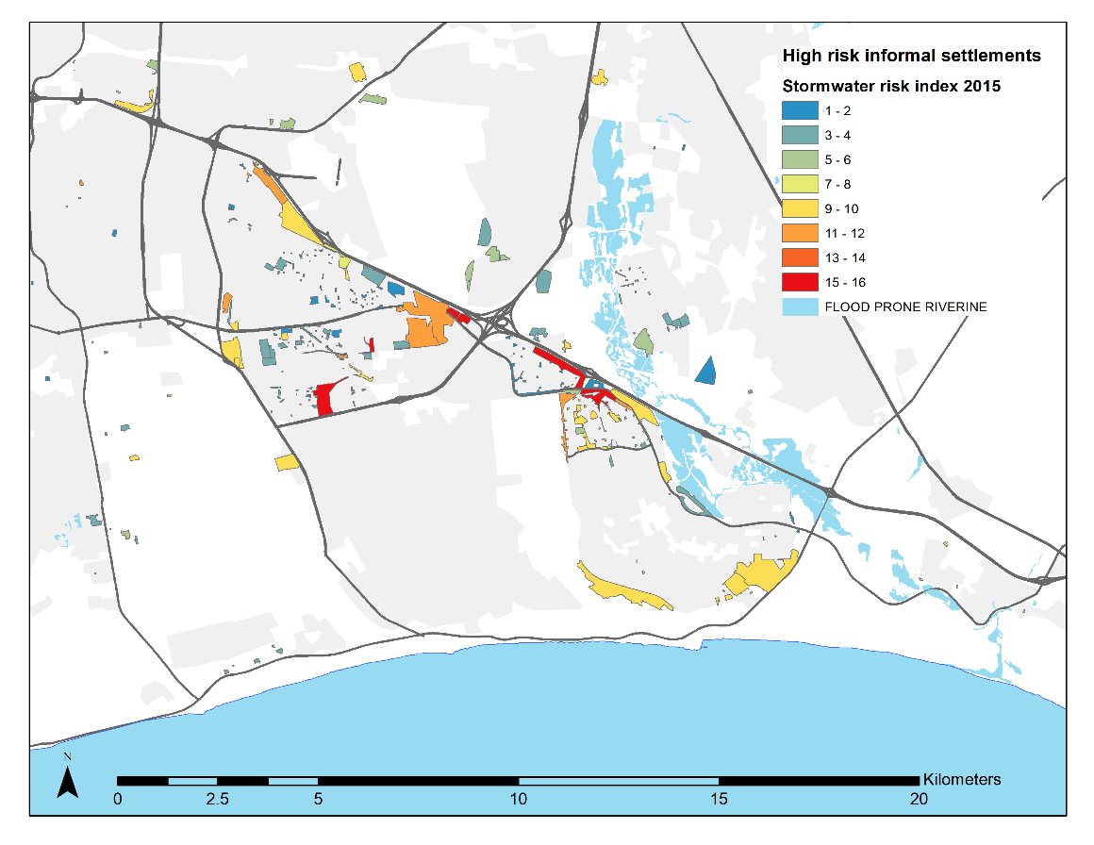

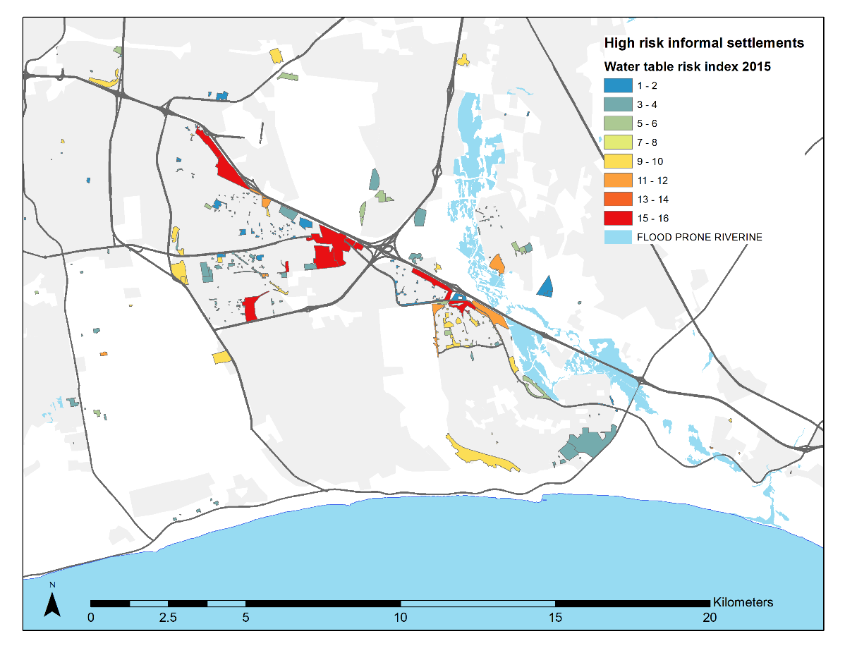

Figure . Annual risk assessment for 2015

Risk index 1-4 = low risk; risk index 5-8 = moderate risk; risk index 9-12 = high risk; risk index 13-16 = very high risk.

The figure above illustrates the results of the annual risk assessment of informal settlements, as a function of probability and impact. Here, approximately half of informal settlements were found to be at low risk of water table or stormwater flooding, whereas 84% of informal settlements were found to be at low risk of riverine flooding. 16% of informal settlements were found to be at high or very high risk of water table or stormwater flooding, compared to 7% of river flooding.

Based on the risk assessment, the following mitigation and preparedness measures are deployed:

|  |  |
| --- | --- |
|  |  |
| General | * Monitoring of services |
| Health | * Health and hygiene promotion |
| Solid waste | * Cleanliness level to be maintained at level 2 during winter period * Vegetation around toilets cleared and ground stabilized * Clean-up operation required in area |
| Stormwater | * General clearing and maintenance of stormwater system in and around settlement * Stormwater canal cleaned and unblocked. * Reed trimming to acceptable height. * Increase canal / system capacity. * Detention pond cleaning and maintenance. |
| Roads | * Access roads to be graded and stabilized * Access road interlinks to be rehabilitated. * Construction of access roads for services to gain access. |
| Disaster management | * Awareness and preparedness education * Early warning * Emergency relief |
| Housing | * Sand * Re-blocking and/or relocation * Relocation (unlikely / not possible) * Monitoring and evaluation of mass care centres |
| Sewer and sanitation | * Toilet infrastructure maintenance (blockages and leaks) * Sewer manhole and reticulation system maintenance * Toilets raised |

### Types of interventions deployed (2018)

Based on an analysis of the 2018 risk assessment, 710 area-based interventions were deployed in 30 high-risk informal settlements. By far the most common types of interventions are short-term- cleaning of storm water system (196) and hygiene promotion (172). Moving toilets, monitoring and maintaining enhanced sanitation services and awareness raising also featured prominently. Longer term solutions such as re-blocking (3) and relocation (47) also featured.

Figure . Types of interventions

### Long-term interventions

In 2004 South Africa became one of the few countries to develop a national policy on informal settlement upgrading, where in situ upgrading was promoted as more responsive to poverty and vulnerability than relocation. High water tables and problems with flooding are mentioned, and the programme encourages rehabilitation measures such as improved drainage, water intervention and engineering of steep slopes. Such upgrading is arguably limited in informal settlements located in particularly disaster-prone areas, and resettlement is seen as the most viable alternative. There is a general sense that not enough has been done, and the antagonism between informal dwellers and local government persists, visible in continuing service delivery protests. Implementation of housing projects have slowed in recent years and the number of informal settlements growing (Drivdal, 2016). Experimentation with more proactive measures, such as the construction of gravel platforms which serve to raise the ground on which residential dwellings were located (Jordhus-Lier et al., 2019), are less common.

# References

Adelana, S., Xu, Y., Vrbka, P., 2010. A conceptual model for the development and management of the Cape Flats aquifer, South Africa. Water SA 36. https://doi.org/10.4314/wsa.v36i4.58423

Apel, H., Trepat, O., Nguyen Nghia, H., Chinh, D., Merz, B., Nguyen, D., 2016. Combined fluvial and pluvial urban flood hazard analysis: Concept development and application to Can Tho city, Mekong Delta, Vietnam. Nat. Hazards Earth Syst. Sci. 16, 941–961. https://doi.org/10.5194/nhess-16-941-2016

de Waal, J.H., Chapman, A., Kemp, J., 2017. Extreme 1-day rainfall distributions: Analysing change in the Western Cape. South Afr. J. Sci. 113, 1–8. https://doi.org/10.17159/sajs.2017/20160301

Desportes, I., Waddell, J., Hordijk, M., 2016. Improving flood risk governance through multi-stakeholder collaboration: a case study of Sweet Home informal settlement, Cape Town. South Afr. Geogr. J. 98, 61–83. https://doi.org/10.1080/03736245.2015.1052842

Drivdal, L., 2016. Flooding in Cape Town’s informal settlements: conditions for community leaders to work towards adaptation. South Afr. Geogr. J. 98, 21–36. https://doi.org/10.1080/03736245.2015.1052839

GroundUp, P.L. for, 2020. GroundUp: Business is booming for shack builders in Dunoon [WWW Document]. Dly. Maverick. URL https://www.dailymaverick.co.za/article/2020-08-14-business-is-booming-for-shack-builders-in-dunoon/ (accessed 8.17.20).

Holloway, A.J., Roomaney, R., Pharoah, R., Solomon, F.J., Cousins, D., 2008. Weathering the storm: Participatory risk assessment for informal settlements. Disaster Mitigation for Sustainable Livelihoods Programme (DiMP).

Huang, H., Chen, X., Wang, Xianwei, Wang, Xina, Liu, L., 2019. A Depression-Based Index to Represent Topographic Control in Urban Pluvial Flooding. Water 11, 2115. https://doi.org/10.3390/w11102115

Informal settlements in Cape Town provided with flood kits, sandbags [WWW Document], 2020. . SABC News - Break. News Spec. Rep. World Bus. Sport Cover. South Afr. Curr. Events Afr. News Lead. URL https://www.sabcnews.com/sabcnews/informal-settlements-in-cape-town-provided-with-flood-kits-sandbags/ (accessed 8.21.20).

Jordhus-Lier, D., Saaghus, A., Scott, D., Ziervogel, G., 2019. Adaptation to flooding, pathway to housing or ‘wasteful expenditure’? Governance configurations and local policy subversion in a flood-prone informal settlement in Cape Town. Geoforum 98, 55–65. https://doi.org/10.1016/j.geoforum.2018.09.029

Joubert, L., 2013. Rising Waters : working together on Cape Town’s flooding. African Centre for Cities, Cape Town.

Machiridza, R.D., 2013. Exploring and profiling of childhood illnesses in informal settlements in relation to flooding: a case study of Barcelona, Cape Town South Africa.

Ntongana, B.T., 2017. Province orders City of Cape Town to clean up Masiphumelele [WWW Document]. GroundUp News. URL https://www.groundup.org.za/article/province-orders-city-cape-town-clean-masiphumelele/ (accessed 8.21.20).

One World, 2018. Climate change hazard, vulnerability and risk assessment study to the benefit of the City of Cape Town.

Pharoah, R., 2013. Examining flood-risk in subsidised housing areas in Cape Town.

Pharoah, R., Holloway, A., Fortune, G., 2016. Off the Radar. Severe weather events 2011-2014 and their impact in Western Cape. Provincial Government of the Western Cape, Stellenbosch.

Redelmeier, B.R., 2018. In Masiphumelele’s wetlands, everyone dreads the winter [WWW Document]. GroundUp News. URL https://www.groundup.org.za/article/masiphumeleles-wetlands-shackdwellers-dread-winter/ (accessed 8.21.20).

Shack with a swimming pool and a Table Mountain view [WWW Document], 2020. . TimesLIVE. URL https://www.timeslive.co.za/news/south-africa/2020-07-07-shack-with-a-swimming-pool-and-a-table-mountain-view/ (accessed 8.23.20).

Social Housing Foundation, 2008. Shack rentals in South Africa.

Woods, M., 2009. Rural geography: blurring boundaries and making connections. Prog. Hum. Geogr. 33, 849.

Ziervogel, G., Waddell, J., Smit, W., Taylor, A., 2016. Flooding in Cape Town’s informal settlements: barriers to collaborative urban risk governance. South Afr. Geogr. J. 98, 1–20. https://doi.org/10.1080/03736245.2014.924867

# ANNEX 1: Flooding research

Lack of detailed assessment of inland flooding for whole of CT. The focus of flooding has been primarily related to sea-level rise and coastal flooding, as well as specific areas within the city and/or institutional aspects of flood risk management (One World, 2018, p. 24).

|  |  |  |
| --- | --- | --- |
| Author and year) | Type of study | Relevant findings |
| Bangira 2013 | * Flash flood potential |  |
| Bouchard 2007 | * Flood risk index pilot study in order to create guidelines for community-level structural improvements and effective communication methods for CCT to improve current flood risk management strategies | * Current incident reporting system is underutilized in informal areas, no systematic data collection, and current topographical data insufficient for use in FRI |
| DiMP 2006 | * Assessment of risk and vulnerability of Phola Park informal settlement | * Floods and fires are main risks as perceived by community * Children more at risk of illnesses * Poor building materials and lack of flooring, poor infrastructure in terms of water pipes and standpipes |
| Mauck 2017 | * Assessment of feasibility of implementing Managed Aquifer Recharge as strategy for flood prevention. |  |
| Musungu 2012 | * Collection and development of community-based GIS data in flood-prone informal settlement | * 3 types of flooding were mapped:   + Flooding from underground water   + Flooding from leaking roofs   + Flooding by run-off water * During heavy rainfall, water channeled along roads and built surfaces of neighbouring formal development flows into the settlement. * Responses include use of sandbags and covering floods using blankets and concrete, as well as raising shacks on wood and stones. * Waterborne diseases were correlated with winter flooding events. |
| Rowswell and Fairhurst 2011 | * Climate change projections established and vulnerabilities assessed by sector | * Floods have consequence on health and water, and can lead to immediate loss of human life. * Flooding stresses sewage and stormwater systems leading to water pollution associated with excessive organisms * Increase in waterborne diseases that manifests as diarrhoea and dehydration. |
| Tadross and Johnston 2012 | * Climate change projections established based on downscaled GCMs and vulnerabilities assessed. | * Reduced rainfall may lead to reduction in flooding * Early studies show rainfall intensity has increased, thus increased vulnerability of dense housing, especially constituted by informal structures. |
| Ziervogel | * Study on governance of flood risks | * Constraints to collaborative urban flood risk management include technocratic approaches, lack of capacity, challenges to sharing risk between departments and with residents, political contestation, and short-termism |
| Phaorah 2016 | * “Off the Radar” | * Between 2011 and 2014, the Western Cape was severely affected by five high impact weather events that led to four provincially gazetted flood disasters. All five of the flood-triggering weather processes were associate with identifiable cut-off low (COL) weather systems that respectively passed through the province between 7-9 June 2011, 13-14 July 2012, 7-11 August 2012, 15-17 November 2013 and 6-10 January 2014. The resulting disasters were characterised by widespread flooding, with impacts reported across most of the Western Cape Province. Outside of the Cape Metro, twelve people lost their lives, while more than 23,000 were affected in informal settlements and low-cost housing areas, as well as farms and more affluent areas. Flash-flooding associated with the 15 November 2013 COL forced the rescue of 121 patients from the Mediclinic Vergelegen in Somerset West, the first evacuation of an entire hospital recorded on the continent. The same system affected 18,000 residents in 44 informal settlements within Cape Town (WCDMC, 2013). Government departments (excluding the Western Cape Department of Agriculture) and affected municipalities reported financial losses in excess R 682.8 million. Farm costs and losses linked to COL weather systems and associated flooding were estimated at R 900.5 million, constituting 56.9% of the total. Altogether, total financial costs/losses to government departments, municipalities and the agricultural sector were estimated at R 1.6 billion. * Pharoah 2016 Off the radar |
| Pharoah 2013 | * Flood risk in RDP areas in Cape Town (PhD) |  |

## Local case studies

|  |  |  |
| --- | --- | --- |
| Author (year) | Neighbourhood | Findings |
| (Jordhus-Lier et al., 2019) | Green Park, corner of N1 and R300 |  |
| (Drivdal, 2016) | Graveyard Pond  Egoli  Kosovo | Although residents apply coping mechanisms on a household scale, the common spaces of the settlements continue to become flooded.  Factors which condition chances of adaptation are (1) location of the settlement, (2) external connections and (3) internal consolidation. |
| (Desportes et al., 2016) | Sweet Home | Critical barriers to collaboration in addressing flood risk |

### Green Park

* Community members called for relief measures. However, different households viewed the flooding differently: “Some saw flooding as a problem and a reason to move, others thought they could fix the flooding even though they weren’t doing anything about it. Some people see being flooded as an opportunity to get things – blankets, soups, sails (tarpaulin) (Jordhus-Lier et al., 2019, p. 60).
* CCT alerted of flooding through three institutional channels: (1) local ward councilor, (2) Disaster Risk Management Centre and (3) direct engagement with local community leader.
* People were moving from one side to the next, but there were no more places for people to move anymore that will keep them clear of the water. One of the options was to move some people away but that also doesn’t go down too well with a lot of the community members because its disruptive (Jordhus-Lier et al., 2019, p. 30).
* ISM officers had previously implemented gravel platforms elsewhere in Cape Town.
* There were also problems of flash flooding on the hard surface of the platform.
* CORC (Community Organisation Resource Centre), an NGO affiliated to SDI which supports community-driven, in-situ informal settlement upgrading. CORC specializes in a planning processes known as ‘re-blocking’ which seeks to improve the spatial layouts of settlements, and has signed an MoU with CCT to assist in upgrading informal settlements.
* The central premise in the in-situ approach is that the urban poor choose to live in particular locations because they offer access to a bundle of socio-economic opportunities. Relocation puts all these benefits of place at risk, and should therefore be avoided. Interim improvements often include strengthening shack structures with new materials and re-blocking settlements to allow for walking paths, drainage systems, better emergency access, street lights and bulk infrastructure.

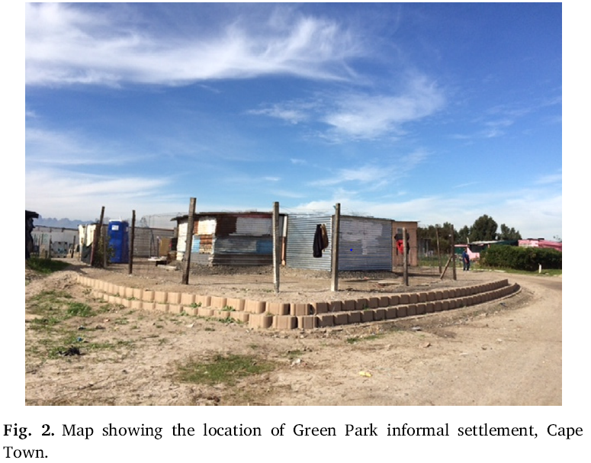

Figure – gravel platforms at Green Park, Driftsands (Jordhus-Lier et al., 2019)

“We are planning to electrify the area, but we could not electrify it because some of the shacks lie in wetlands. The City flags areas as wetlands (Jordhus-Lier et al., 2019, p. 63). The City has to provide map of an area to identify which households were deemed at risk from flooding due to their location in the wetland.

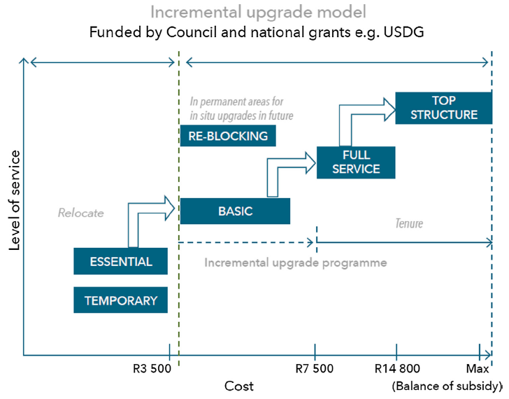

Figure – CCT’s incremental upgrade model (Jordhus-Lier et al., 2019)

### Sweet Home

Environmental factors which contribute to Sweet Home’s vulnerability to flood risk include sandy soils, no vegetation cover, undulating topography with shacks built in low-lying sections, and high water table.

(Desportes et al., 2016)

# ANNEX 2: Resources

## Data sources

Virtually all the data on flood-risk in poor South African communities is qualitative, gathered from interviews, focus group discussions and using participatory risk assessment techniques. There exists nominal quantitative data on flood risk (Pharoah, 2013, p. 92).

The DRMC has a list of flood-prone settlements generated each year in the run-up to the rainy season. These include (1) Kosovo, Sweet Home, Never-Never (Area K), Kanana, and Phola Park.

“Disaster Risk Management officials found approximately 4,000 structures that have been affected in the Khayelitsha, Du Noon, Philippi, Langa, Gugulethu, Masiphumelele, Mfuli, Delft, Hout Bay, Macassar, Sea Winds and Nyanga informal settlements,” Powell said.

## Networks / collaborations

Flooding in Cape Town under Climate Risk (FliCCR) project, funded by the International Development Research Centre and UK Dept. of International Development as part of Climate Change Adaptation in Africa programme. The FliCCR project is located in ACC at UCT and forms part of Mistra Urban Futures programme on urban change. Project leader: Anton Cartwright

<https://www.idrc.ca/en/project/managing-risk-flooding-and-sea-level-rise-cape-town-power-collective-governance>

Research Alliance for Disaster and Risk Reduction (RADAR) at Stellenbosch University

## Online resources

### CKAN Opendata

Data on informal settlements

* Informal settlement upgrade constraints
  + Flood prone score per IS
  + Buildings in wetland per IS

<https://data.openup.org.za/dataset?page=2>

### Informal settlement maps (online)

Drawn mostly from 2015 CKAN data (see above)

[http://ismaps.org.za/desktop.html#](http://ismaps.org.za/desktop.html)

### Floodmap viewer

<https://www.floodmap.net/?gi=3369157>

### CSIR Coastal Flood Hazard online tool

<https://www.ocims.gov.za/hazardlines/#/?_k=bvznwn>

## Contacts

Dr Melanie Luck-Vogel from the CSIR developed a coastal flood risk viewer for improved disaster risk management and development planning.

[mluckvogel@csir.co.za](mailto:mluckvogel@csir.co.za)

## CSIR floods

<https://pta-gis-2-web1.csir.co.za/portal/apps/GBCascade/index.html?appid=33d9a846cf104e1ea86ba1fa3d197cbd>

<https://riskprofiles.greenbook.co.za/>

CSIR Contacts:

David Le Maitre

Natural Resources and the Environment

[DLMaitre@csir.co.za](mailto:DLMaitre@csir.co.za)

Ilse Kotzee

CSIR

Natural Resources and the Environment

[Ikotzee@csir.co.za](mailto:Ikotzee@csir.co.za)